# Production

Preliminary settings

## Creation of raw material nomenclature

Go to the menu item Warehouse - Nomenclature

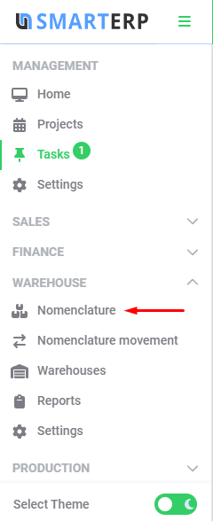

In the opened form, click the “Add Nomenclature” button

(nomenclatures can be imported from an outer system)

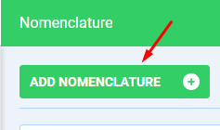

Fill in the name, unit of measure and click “Create”

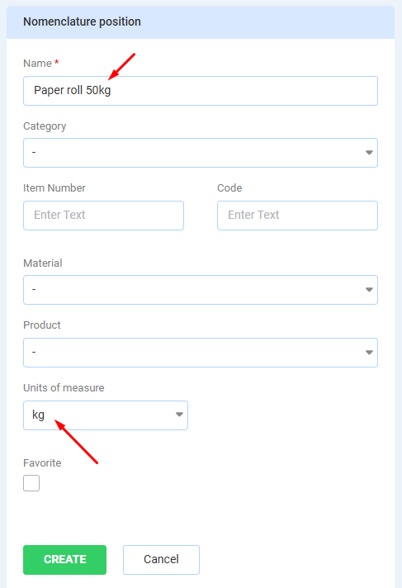

## Materials

Go to the menu item Production - Materials

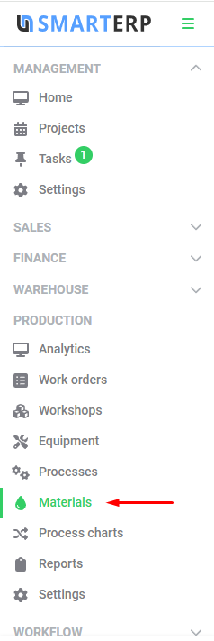

Press “New material”

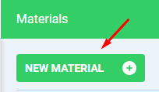

Enter the material name, specify the unit of measure for production and click “Create”.

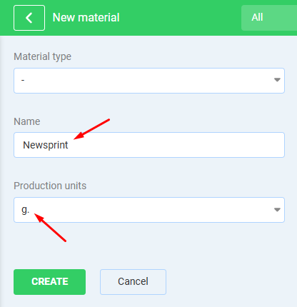

## Adjustment of nomenclature

Go to the menu item Warehouse - Nomenclature, as in step 1.

Select the nomenclature created in that item

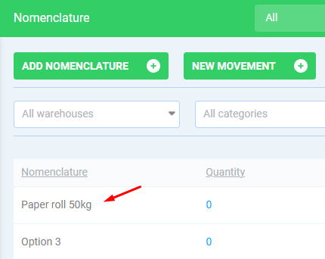

Specify the material created in the previous paragraph.

**IMPORTANT.** It is necessary to specify the ratio of the units of the target material consumption to the incoming material. In the above example, the incoming nomenclature has a weight of 50 kilograms, and the consumption of this material will be in grams - so the ratio is 50000.

After entering the data, click “Save”.

Later, when there will be movements on this nomenclature, it will be impossible to change the ratio.

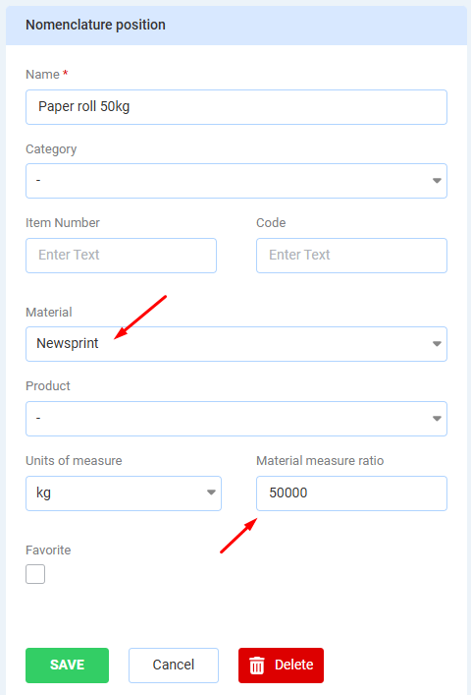

## Income

Go to the menu item Warehouse - Nomenclature movements

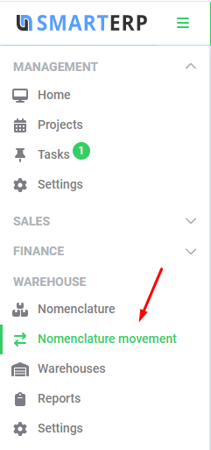

Click New Movement

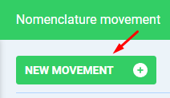

In the opened form, select the “Arrival” transfer type.

Next, fill in the destination warehouse, select the created nomenclature from the previous step, select the date of arrival and specify the quantity. After that press “Save”

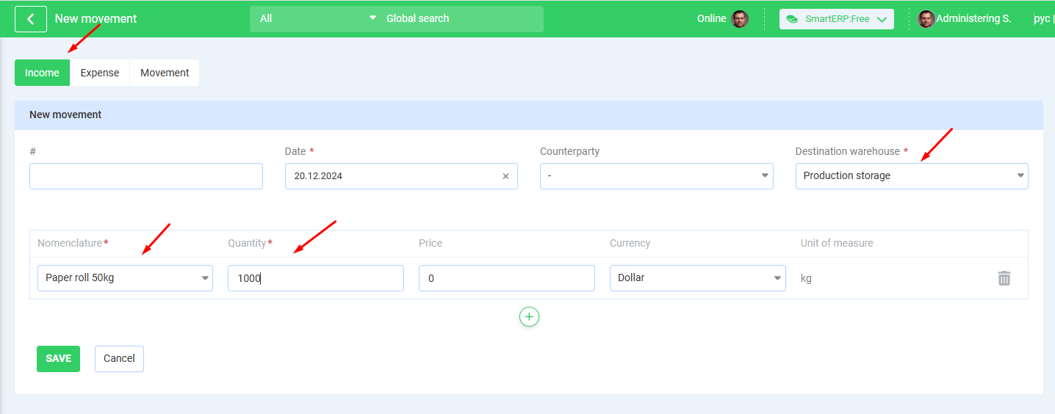

After that, a record of the created income will appear in the list of nomenclature movements

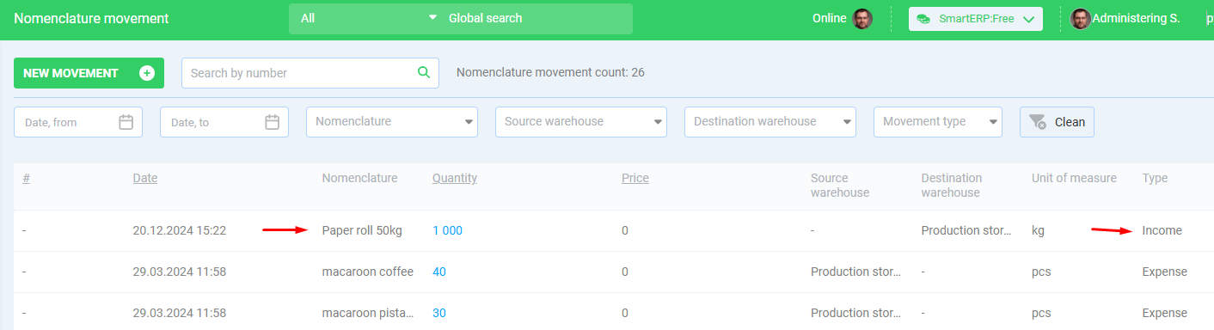

## Catalogue

Go to the menu item Sales - Catalogue

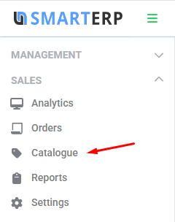

Select a category in the catalog

If the desired category does not exist, you can create it via the “New Category” button

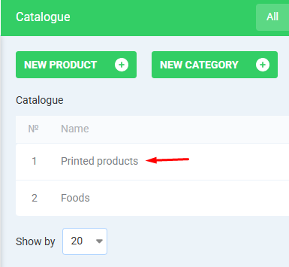

Click “New Product” in the selected category

Enter the product title, fill in the rest of the fields and click “Create”

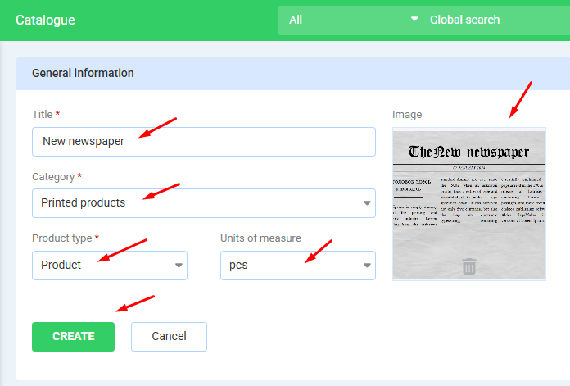

After creating a product in the catalog, you must create all nomenclatures of finished products with all variations, similarly to step 1

IMPORTANT - it is necessary to assign the nomenclature to the corresponding product .

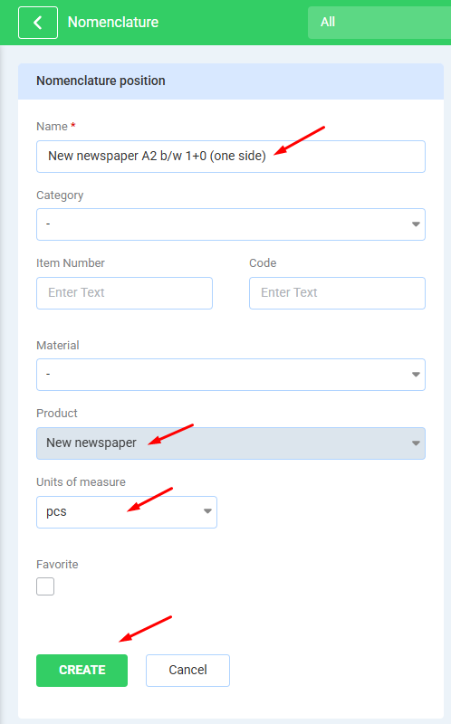

The list of nomenclatures is about to look something like this:

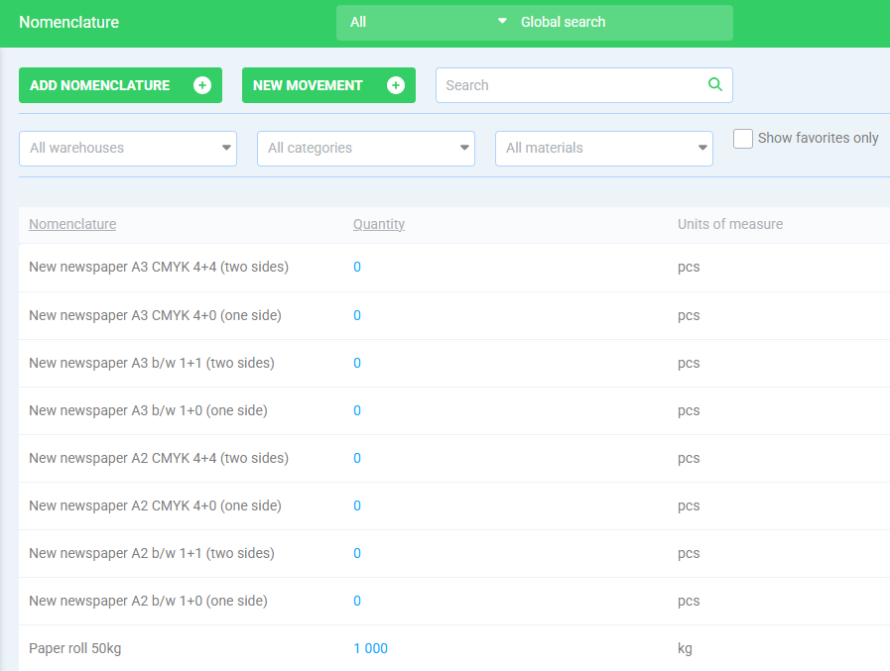

Go to menu item Sales - Settings - Features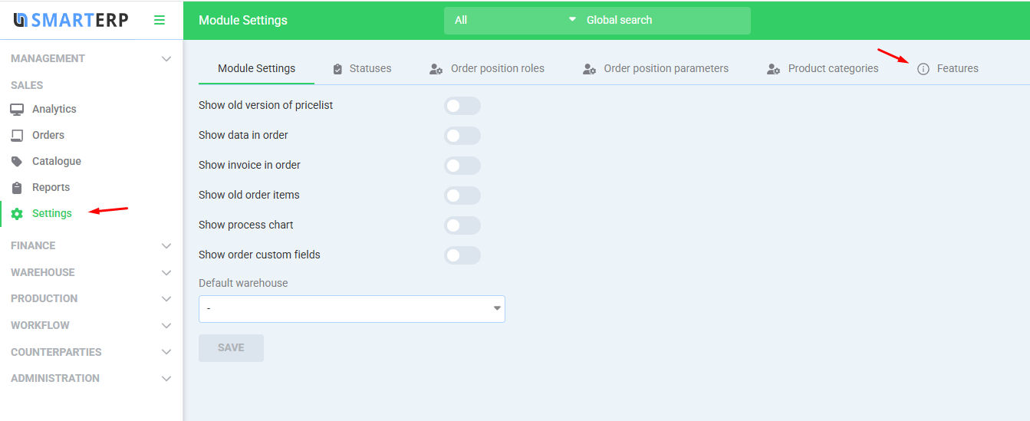

Now you need to create two characteristics - Newspaper Format and Newspaper Color.

To do this, click “create feature”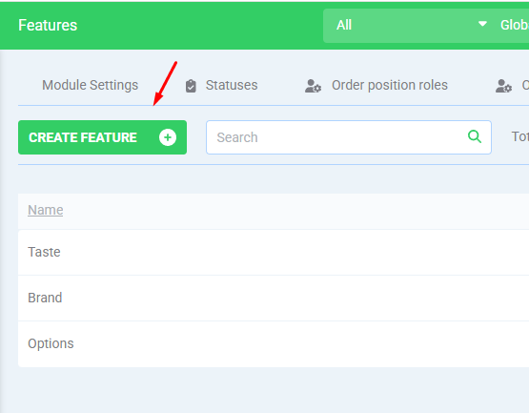

Fill in the feature data and click the plus button. Usually the “List” feature type is used.

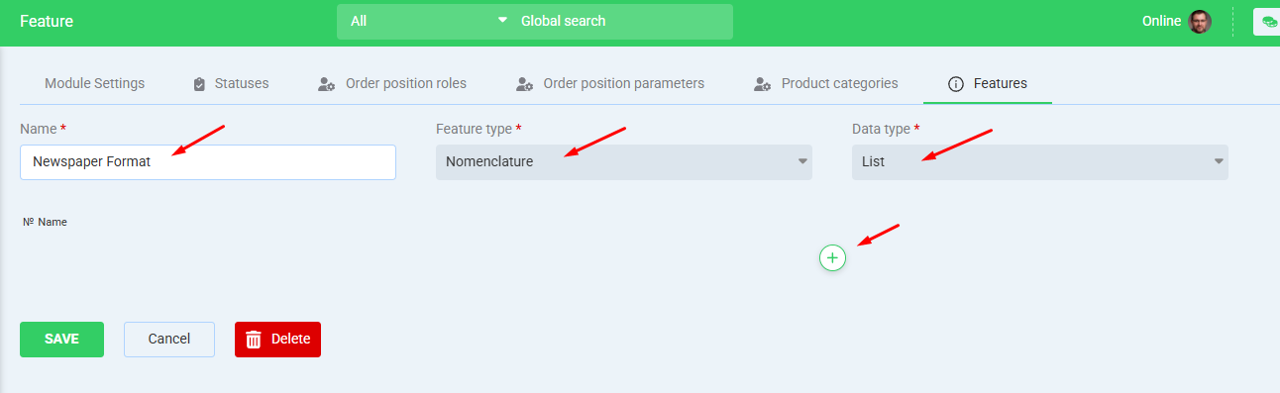

Add the desired feature options and click Save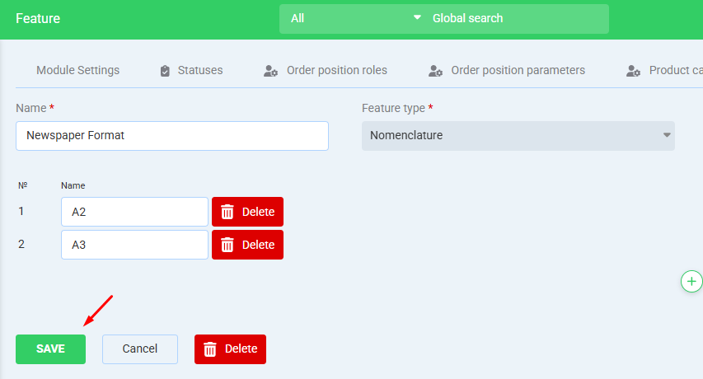

Add a second feature in the same way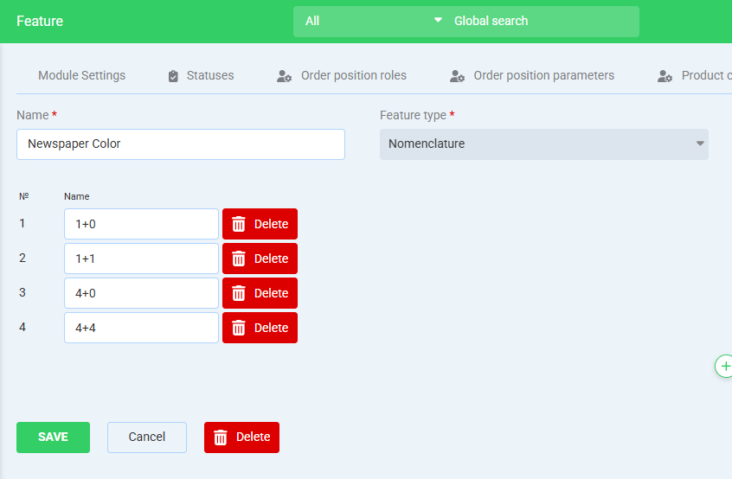

Go back to the menu item Sales - Catalogue and enter your new product.

Add the required features by selecting them in the list and they will appear in the nomenclature.

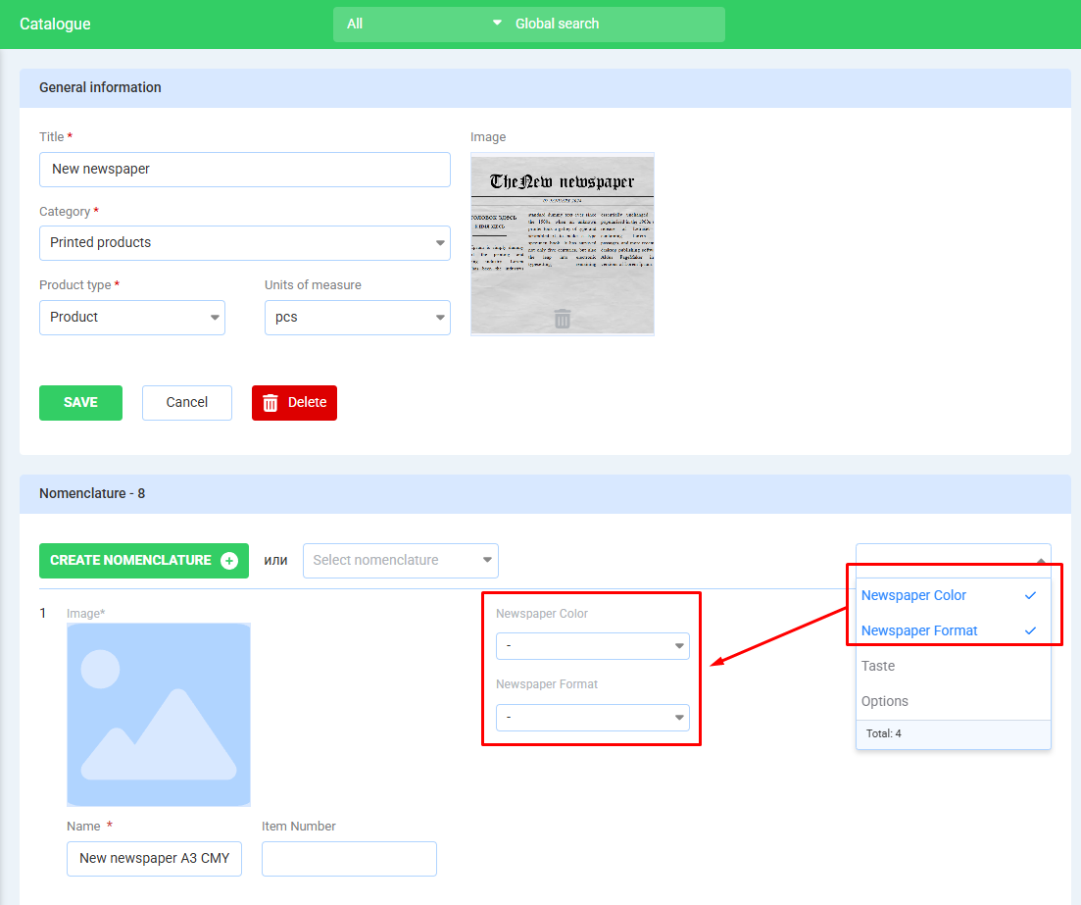

Select the desired features, in this example we will base on the nomenclature names

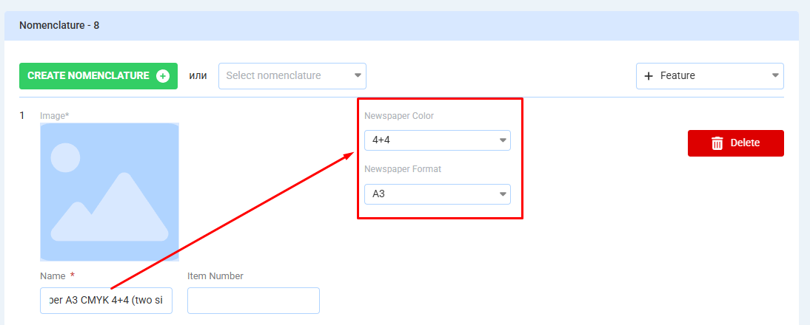

**In this way add features to all created nomenclatures**

As a result, this product in the catalogue should look like this:

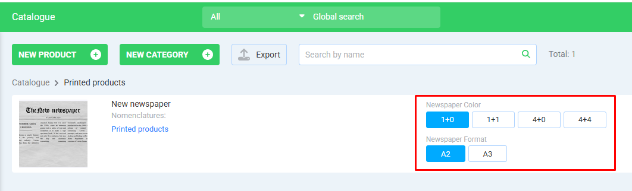

## Process chart

Go to the menu item Production - Process charts and click “New process chart”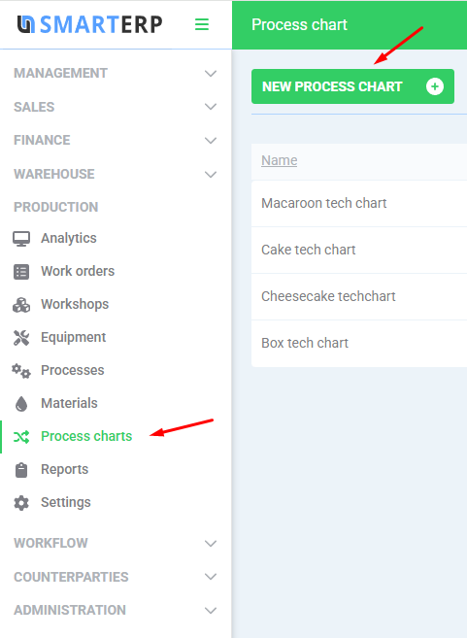

Fill in the name of the process chart, select the product and click “Create”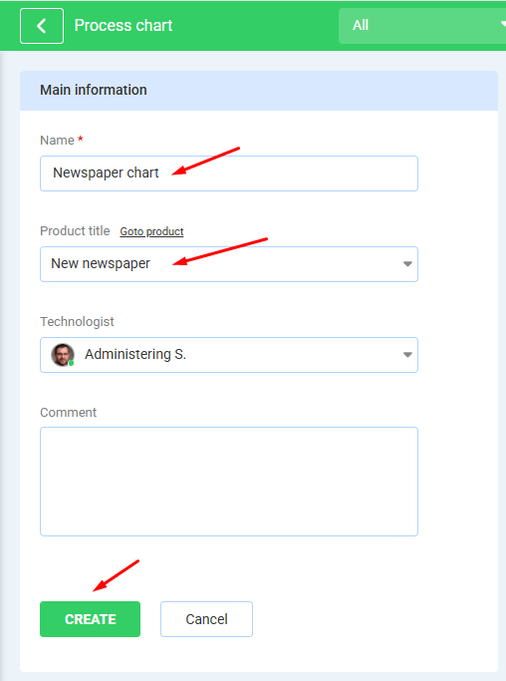

## Adding processes

Click “Add process”

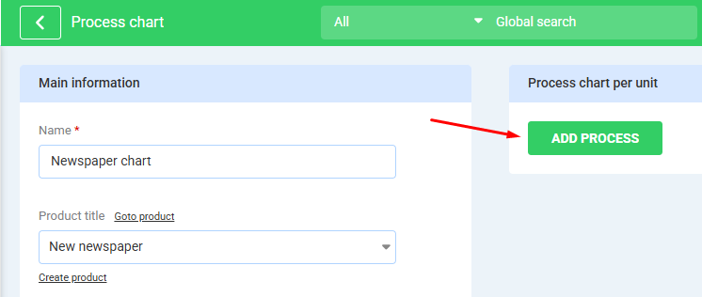

In the process filling form, you must select:

* The workshop that performs the process
* The warehouse from which the materials for the process are sourced
* Equipment to be used
* The process itself

If necessary, you can also fill in the expected process time and cost price.

Click the Save button

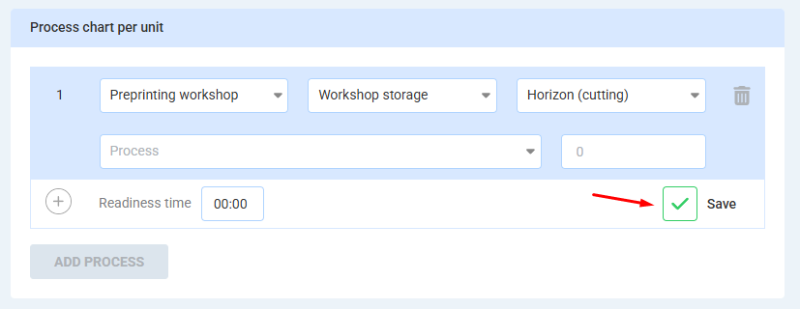

Now you need to select the materials to be used, to do this press the plus button

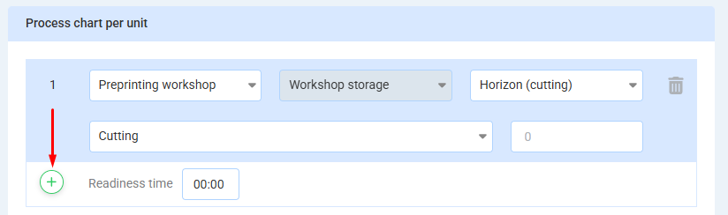

Select the desired material

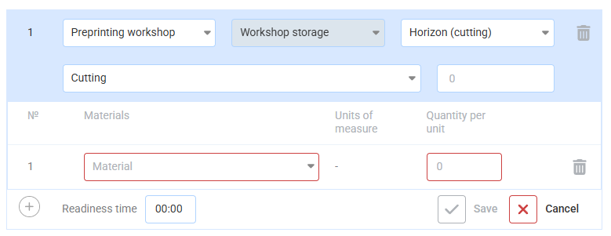

Select the created material and enter the material consumption for this process and click the Save button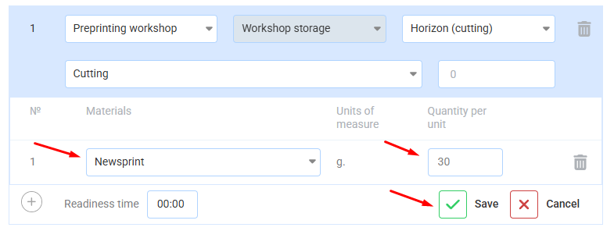

Use the plus button to add all the materials used in the process, remembering to save them.

In the same way, add all necessary processes via the “Add process” button

Here is an example of a completed flow

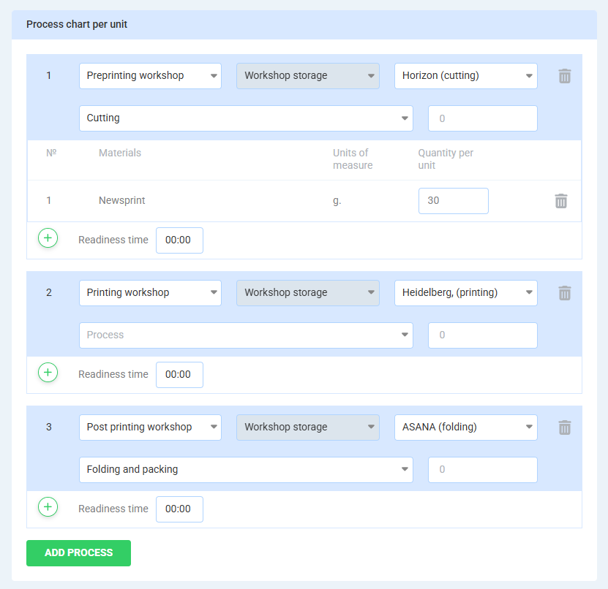

The preliminary settings are now complete

## Orders

Go to the Sales - Orders menu item and click “New Order”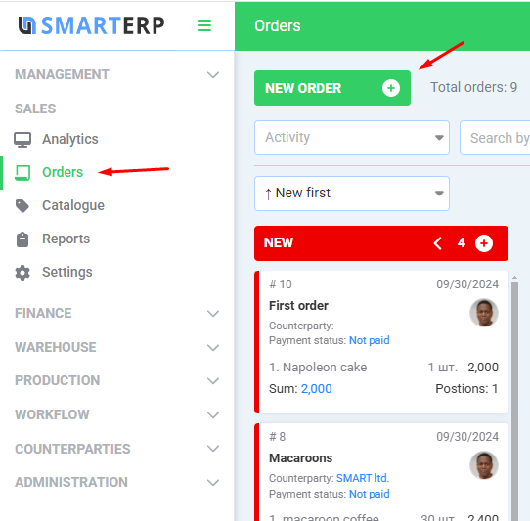

Fill in the order details and click “Create”.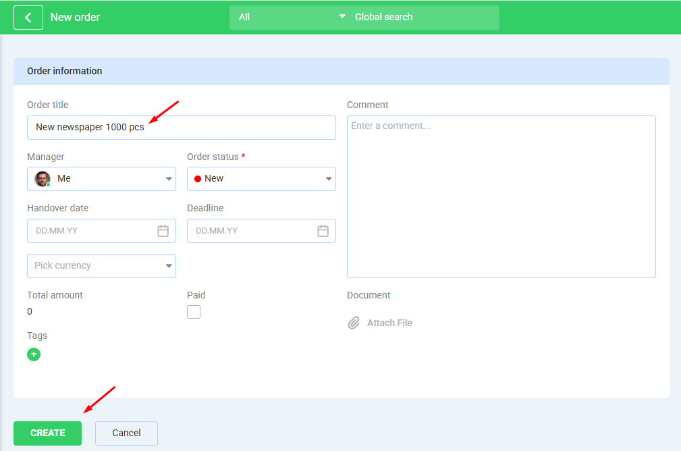

After saving the order, go to the “Positions” tab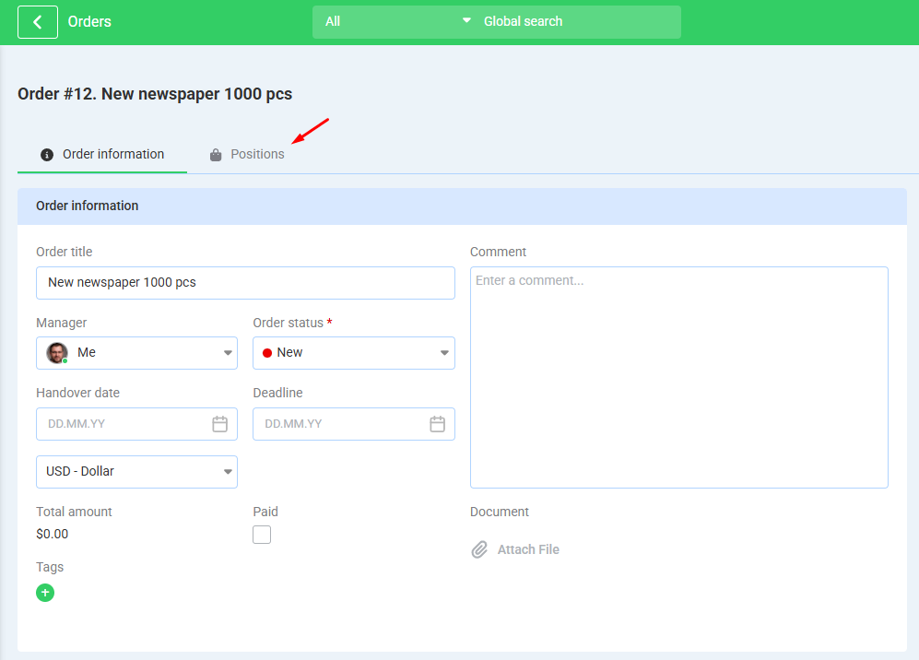

Click “Add Position”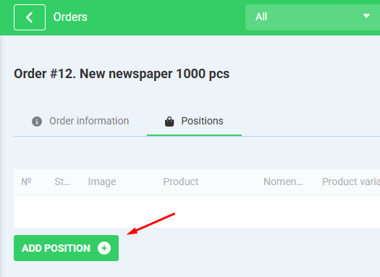

Choose the product

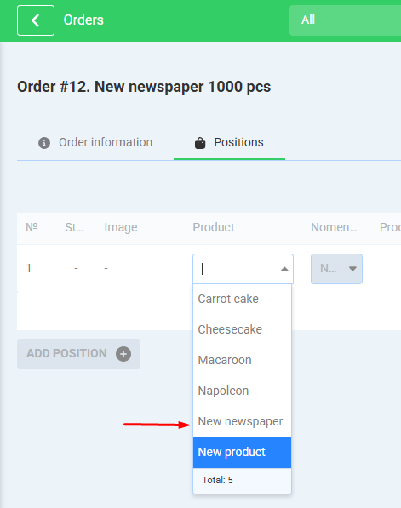

In case your product is missing in the list, check the created nomenclature and its binding to the product in the catalogue.

Select the order issue warehouse. The balance of the required item in this warehouse is also shown there.

Select the required characteristics (nomenclature).

Fill in the price and quantity for the order.

If price ranges depending on quantity have been specified in the catalogue, the total amount will be calculated automatically. If it is not calculated, you can enter it yourself in the “Quantity” field or edit the calculated amount if desired.

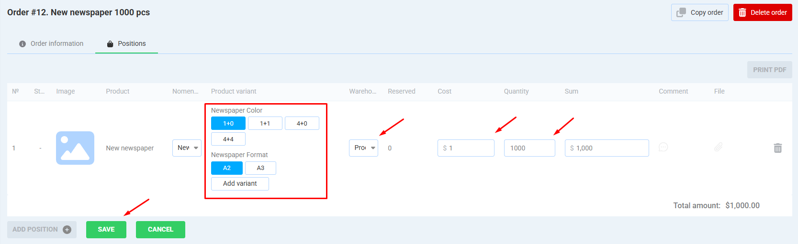

After that, click “Save”

Since the selected warehouse does not have sufficient quantities for this order, the “Send to production” button appears. Click it.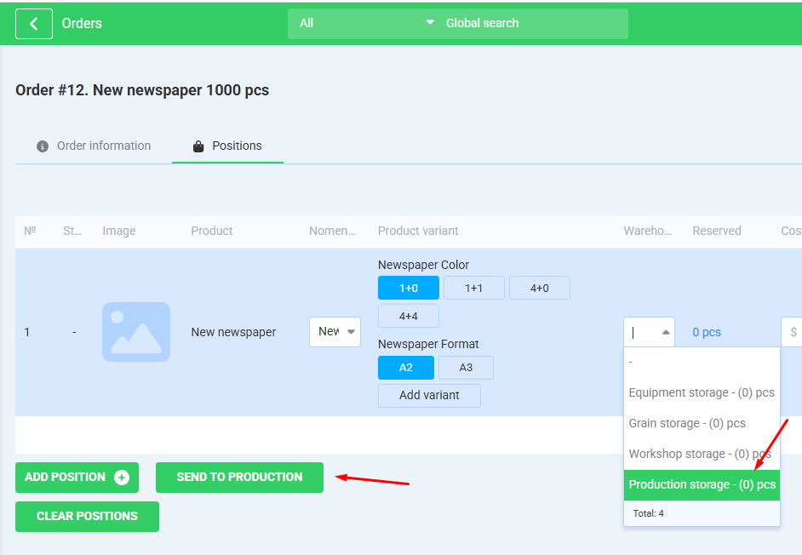

The order has been sent to production

## Work orders

Go to the menu item Production – Work orders. Your work order is in the “New” status

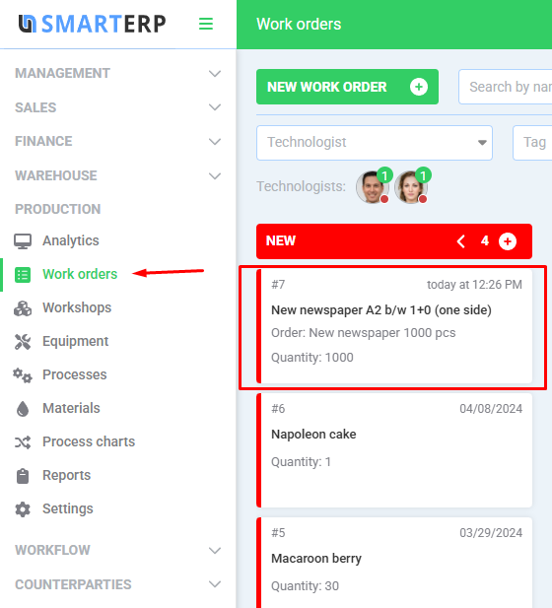

Go into the work order and select the flow chart created in step 6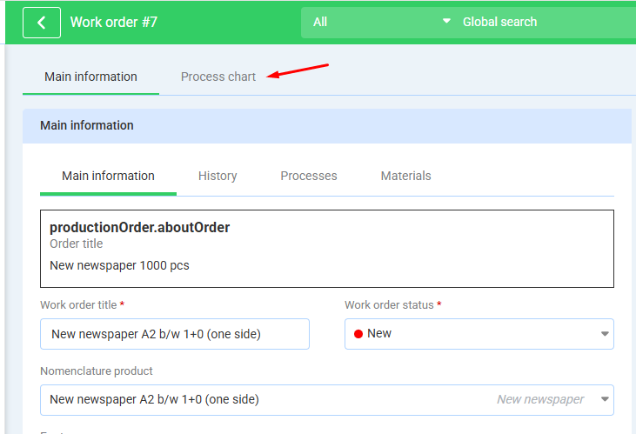

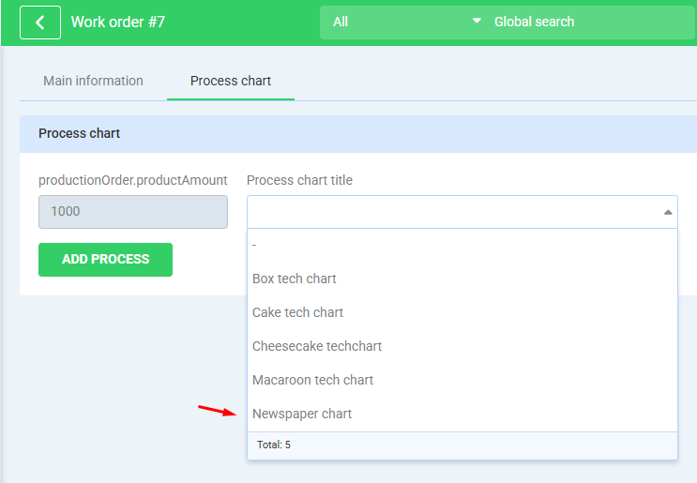

Click “Apply process chart”

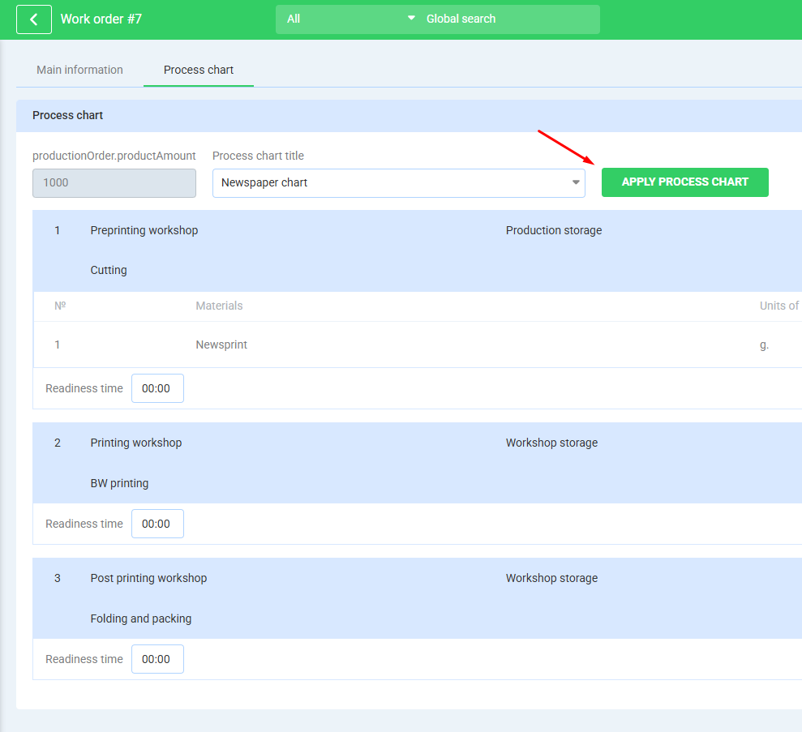

Select the technologist and the current status of the work order.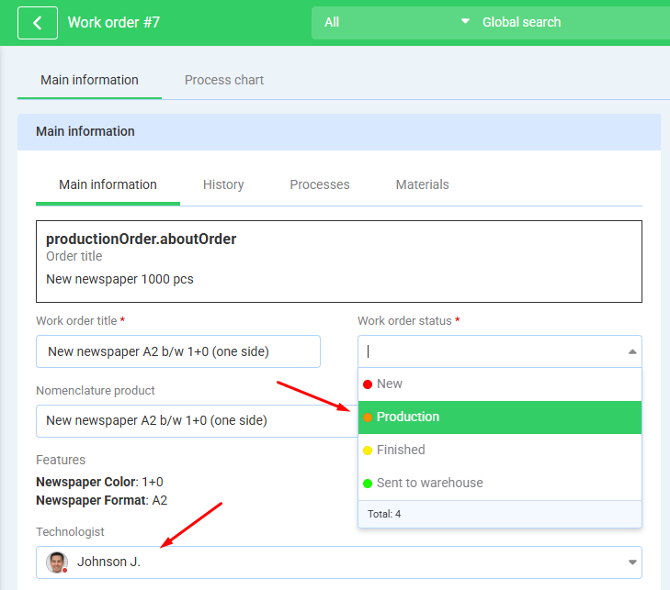

Click “Save” below

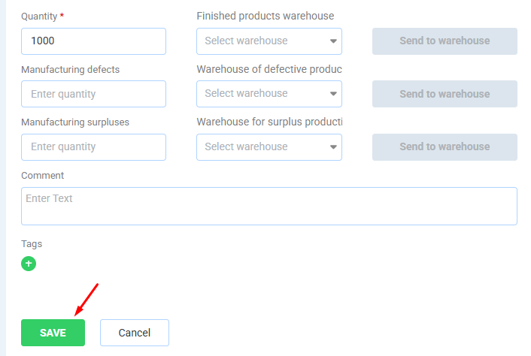

Select process responsibles and click the Save button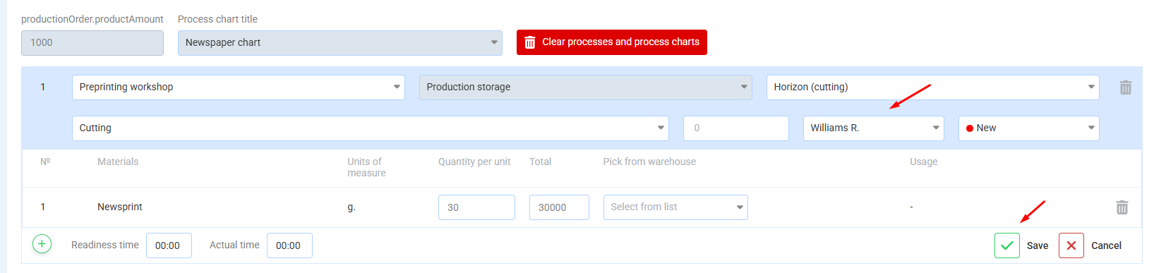

The assigned responsible sets the status “Production” to reflect that the process is in progress.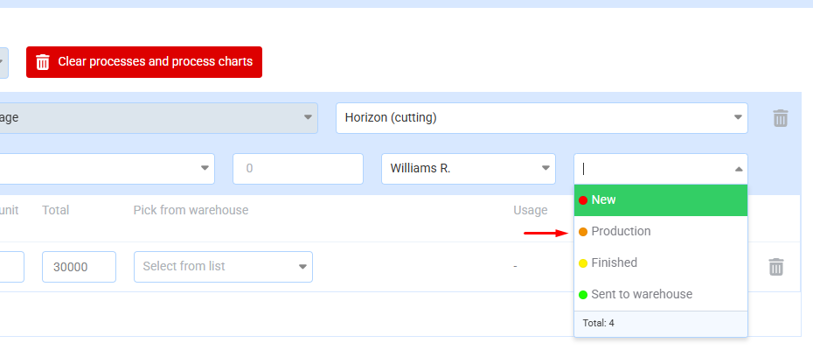

Исполнитель по данному процессу выбирает используемый материал с доступного склада, где сырье в наличии

The assigned responsible selects the material to be used from an warehouse where raw materials are available

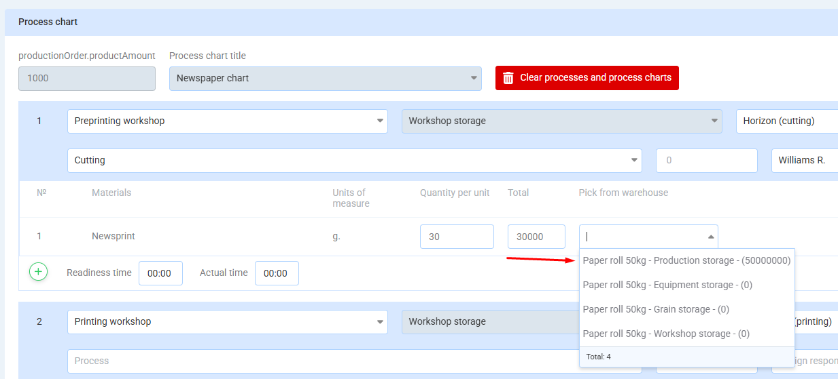

After that it is necessary to press the button to move the material from its storage warehouse to the warehouse of the corresponding workshop. This will create a nomenclature movement record.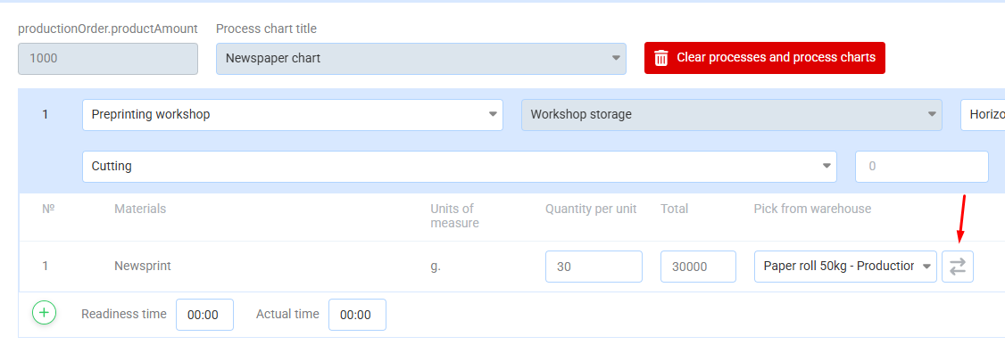

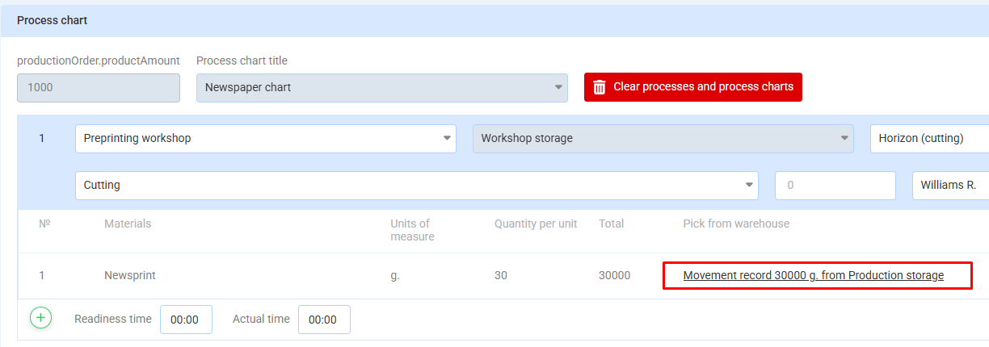

Next, write-off the material that will be used in production for this process.

The amount of raw materials to be used is calculated in the “Consumption” field based on the flow chart and the order volume; if necessary, you can set the actual consumption different from the calculated one.

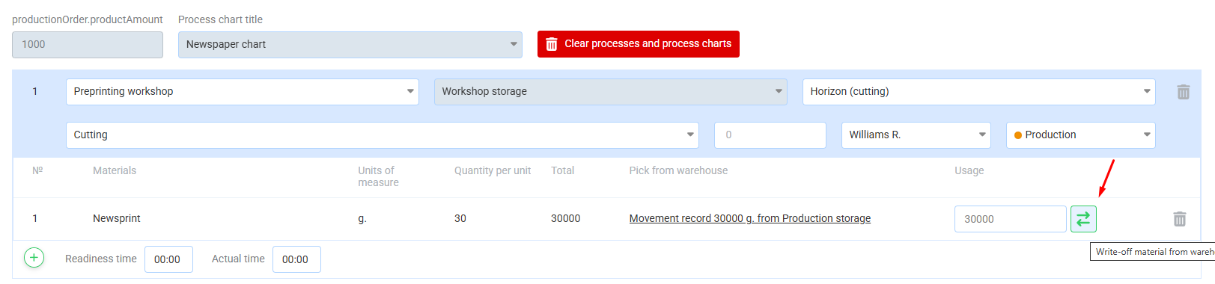

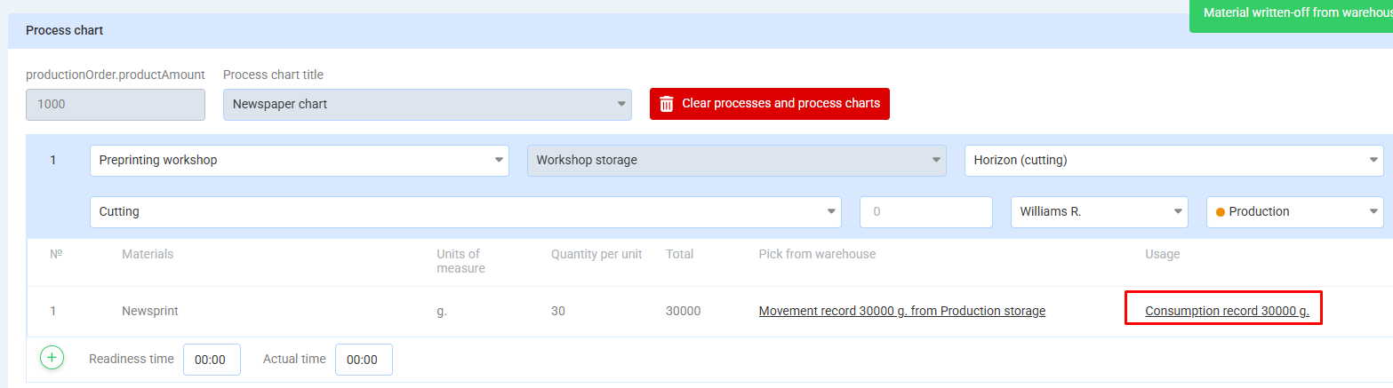

When material is written off from the warehouse, an entry is also created in Nomenclature Movement

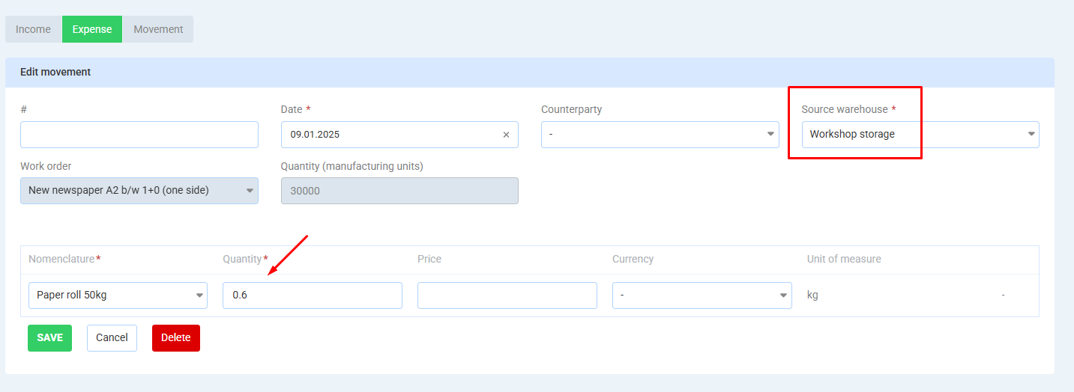

The consumption is indicated both in production units and in the units of measurement specified when the material was received

This is how the chart looks like when all processes are complete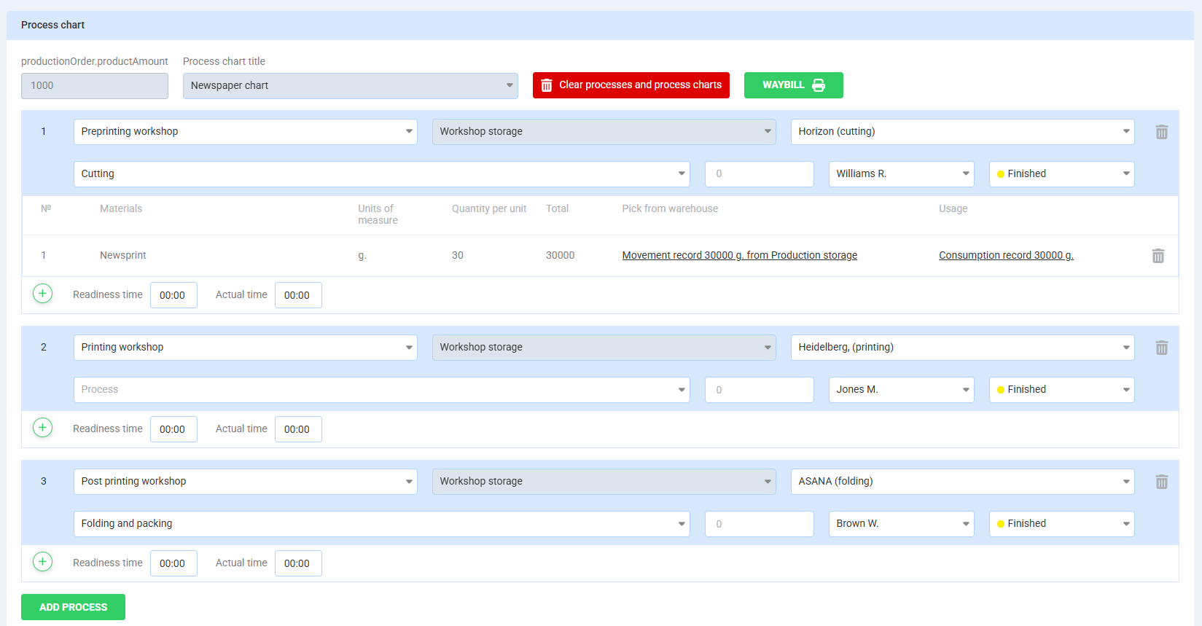

The technologist can then put the appropriate status alongside, send the received goods to the finished products warehouse and click “Save”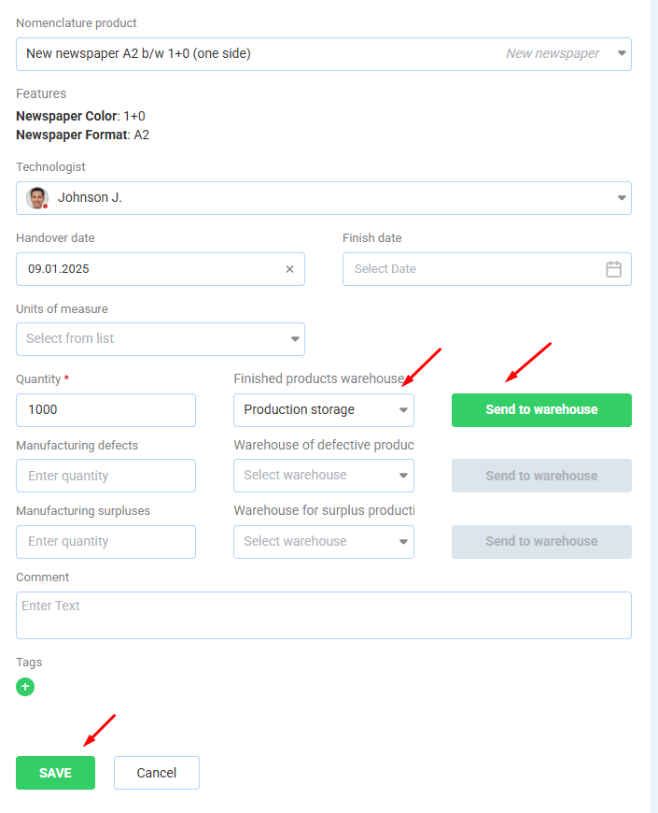

A link to the corresponding warehouse movement is created in the work order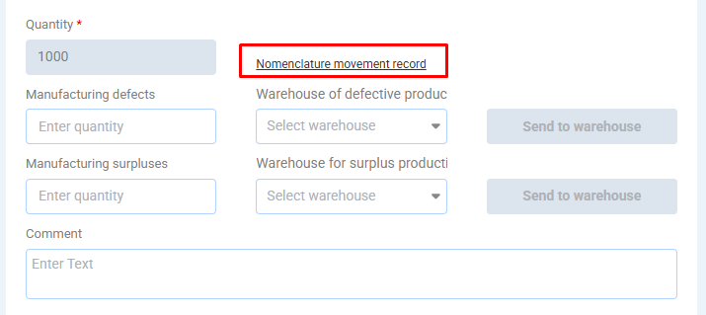

Here's the record itself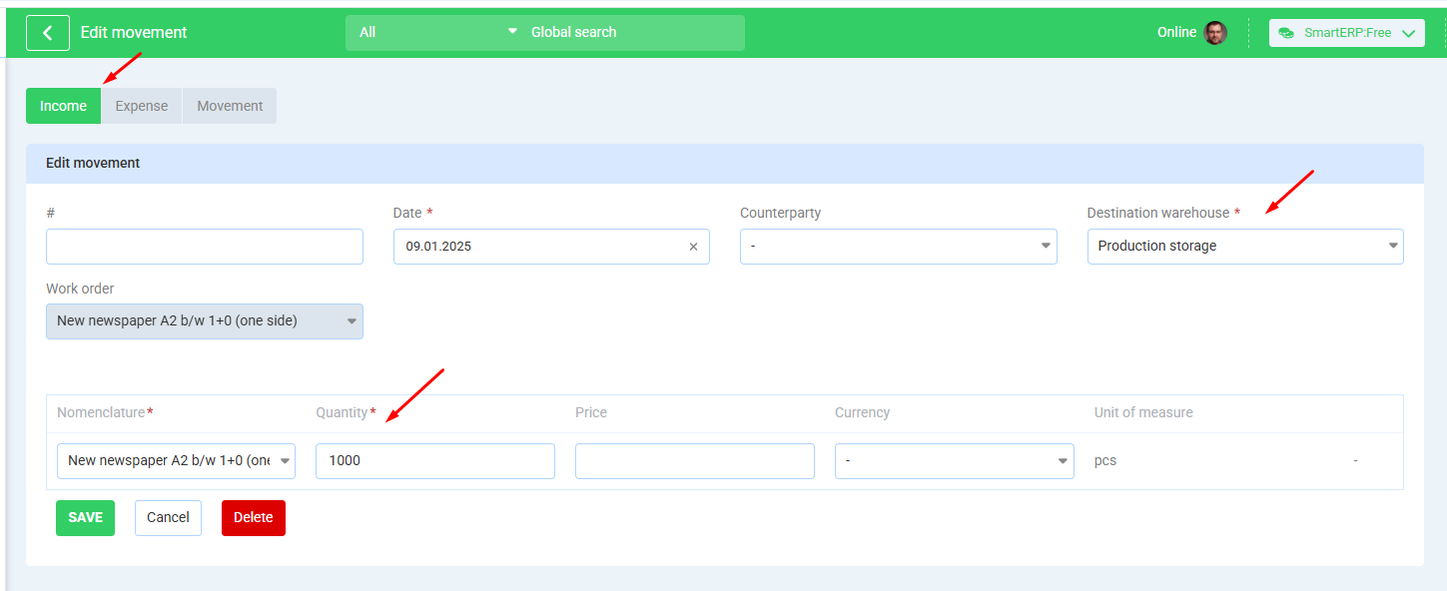

The order position tab shows the picture below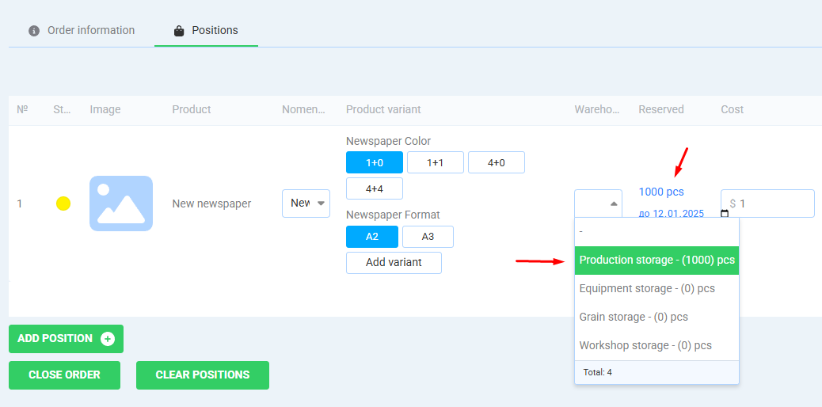The quantity received is appered in the warehouse, it is also reserved for this order.

The “Close order” button writes off (gives out) the goods to the customer