# Documents

Let's consider the work of the Workflow module.

To work with the module it is necessary to make preliminary settings.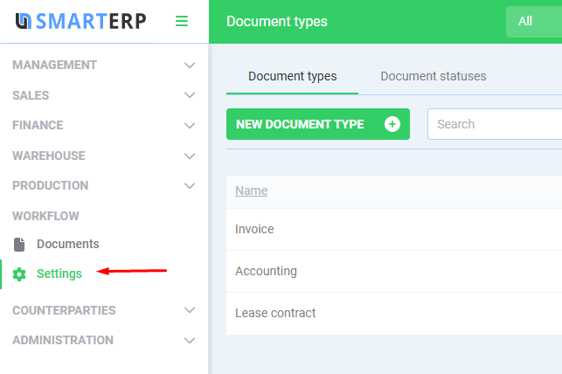

## Document types

In this directory you can maintain the types of documents you need.

Examples of document types: orders, acts, contracts and so on.

## Document statuses

This directory can also be maintained in a free form. You can create any statuses of documents, for example, urgency or stage of completion grades.

The number of types and statuses is unlimited.

## Working with documents

The top panel has the following controls.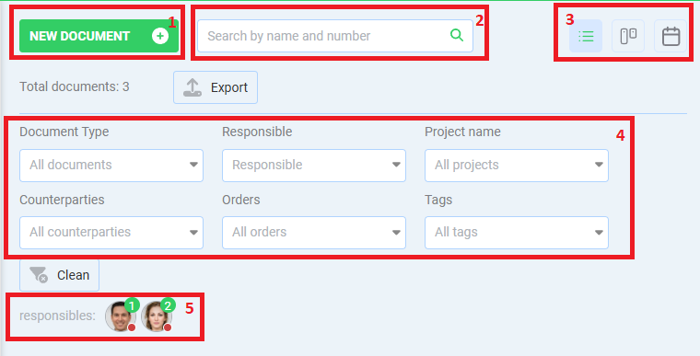

1. Create a new document
2. Quick search
3. Switching the display mode:

* List
* Kanban. In this mode the columns for kanban will appear as the statuses of documents
* Calendar. The document becomes an event in calendar by the closing date

1. Filters by the corresponding fields
2. Filters by responsible executors to whom documents are assigned

### Creating document

Let’s create a document

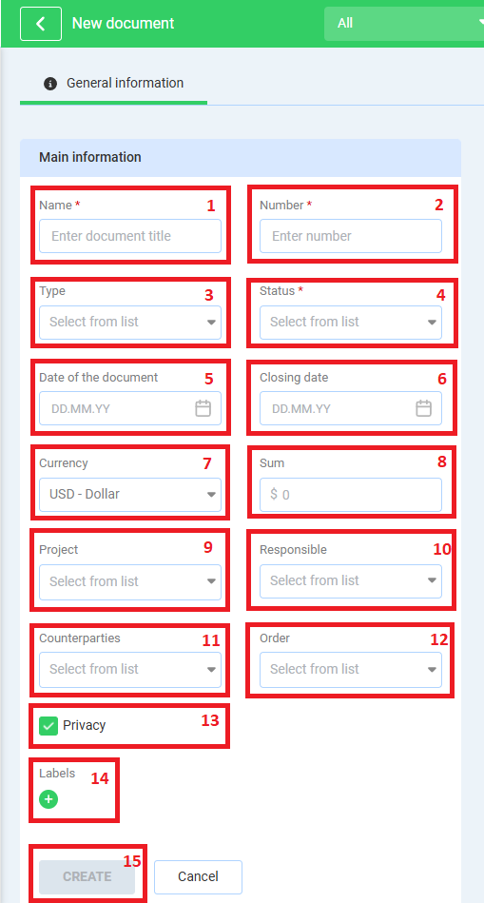

* 1. Name of the document, required field
  2. Document number must be unique. Required field
  3. Document type. Determined from the directory entered here
  4. Status. Documents on the Kanban are arranged by the status order
  5. Date of the document
  6. Closing date. Document is located on the calendar by this date
  7. Currency of the document
  8. Document amount. Can refer to contracts, advance reports, and so on
  9. You can select Project from the Management module the document relates to. The selection can be multiple
  10. Responsible for the document
  11. Counterparty the document relates to. The choice can be multiple
  12. Order the document relates to. The selection can be multiple
  13. Document privacy. Enabled by default. A private document is visible to the creator and the responsible person only. Otherwise, the document is visible to everyone
  14. Document tags
  15. Document creation button, will be available if required fields are filled in

### Document editing

After creating a document, you can enter it again for further work with the document.

Additional tabs appear here.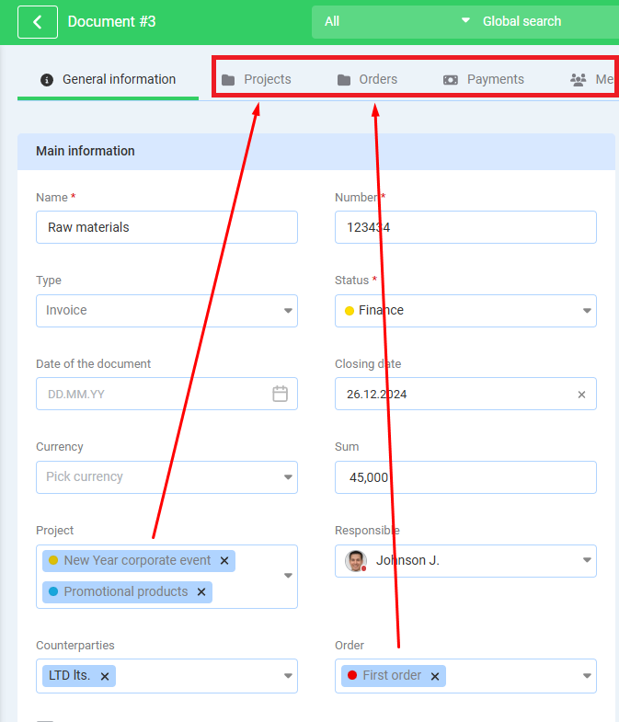

* Projects

This tab shows Projects the documents relates to

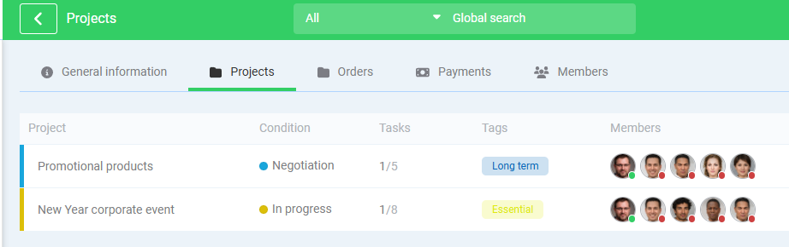

You can proceed to a project by click it in the list (**Management** module)

* Orders

Similarly, the Orders tab displays orders related to the document (**Sales** module)

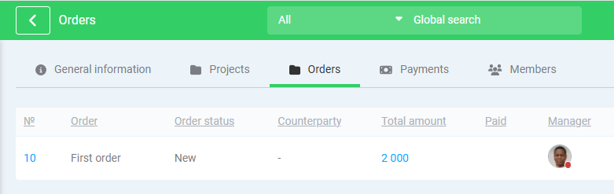

* Payments

The Payment tab displays transactions relates to the document (**Finance** module)

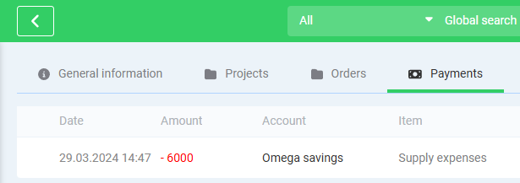

* Members

You can add members to the document here

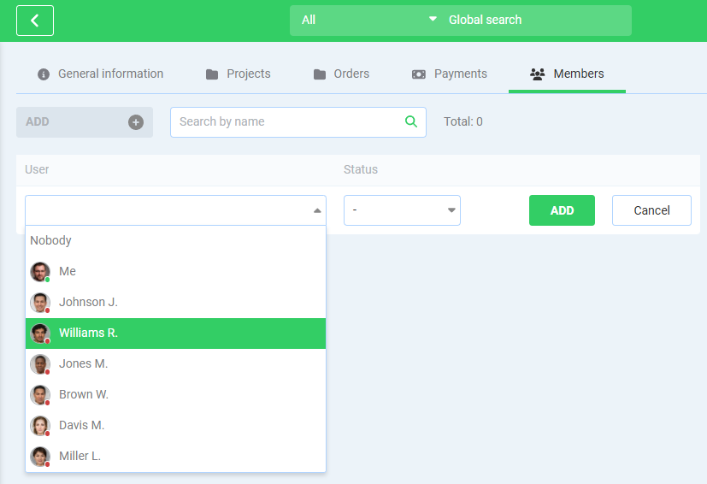

Document members can access to a document with Privacy set

Let’s get back to the general information tab

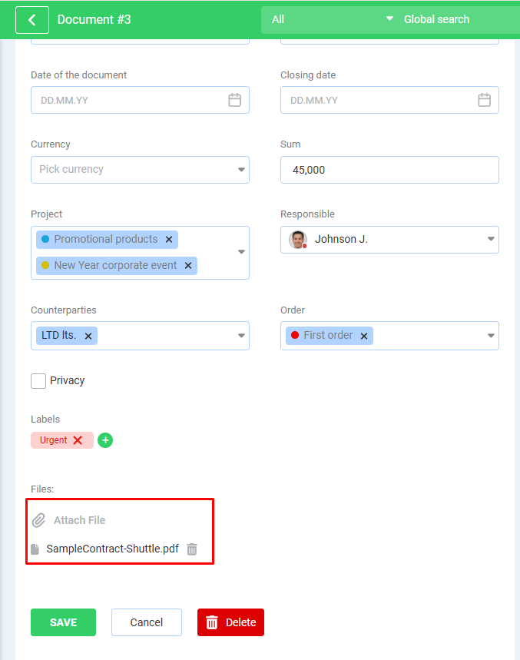

You can attach a document itself here. Save changes after attaching or removing files.

Some document filetypes can be displayed on the right side in preview mode

